Session 17: RDD'S IN SPARK
Assignment 17.2

Problem Statement
Problem Statement 1:
1. Read the text file, and create a tupled rdd.
2. Find the count of total number of rows present.
3. What is the distinct number of subjects present in the entire school
4. What is the count of the number of students in the school, whose name is Mathew and
Marks is 55

Problem Statement 2:
1. What is the count of students per grade in the school?
2. Find the average of each student (Note - Mathew is grade-1, is different from Mathew in some
other grade!)
3. What is the average score of students in each subject across all grades?
4. What is the average score of students in each subject per grade?
5. For all students in grade-2, how many have average score greater than 50?

Problem Statement 3:
Are there any students in the college that satisfy the below criteria:
1. Average score per student_name across all grades is same as average score per student_name
per grade
Hint - Use Intersection Property.

Dataset
Given a dataset of college students as a text file (name, subject, grade, marks):
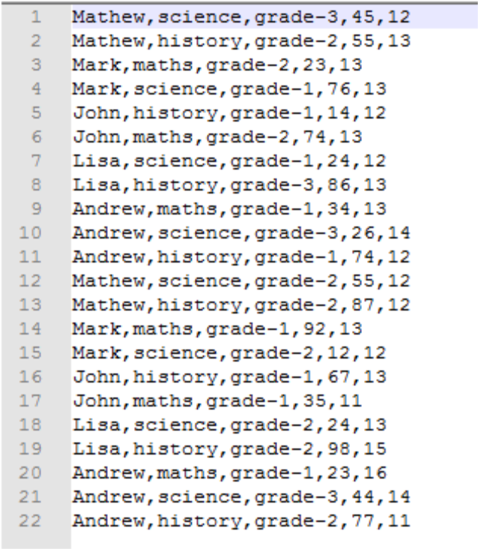

Spark Operations – Problem Statement 1

Task 1.1 Read the text file, and create a tupled rdd.

Below is the code we use to read the text file using spark context and creating a tuple RDD,
scala> val baseRDD = sc.textFile("/home/acadgild/hadoop/17.2_Dataset.txt").map(x =>
(x.split(",")(0),(x.split(",")(1),x.split(",")(2),x.split(",")(3).toInt,x.split(",")(4).toInt)))

scala> baseRDD.foreach(println)
We have create a tuple RDD with name as Key and the subject, grades and the marks as values.
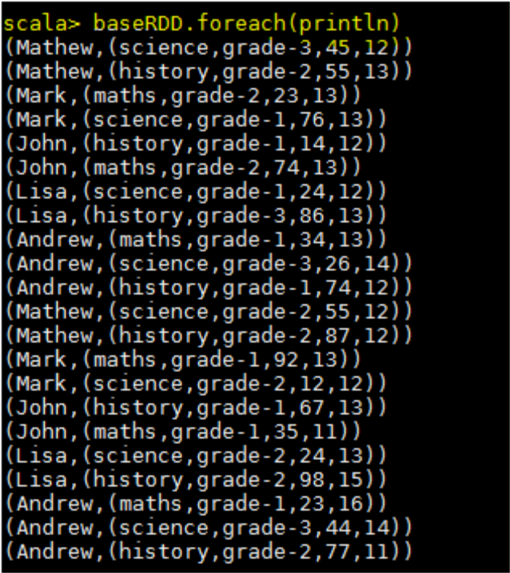
Task1.2 - Find the count of total number of rows present

scala> baseRDD.count()

res1: Long = 22

By using count() function we can see the number of lines present in the text file.
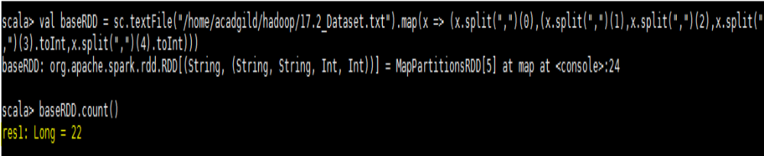
Task1.3 - What is the distinct number of subjects present in the entire school?

Please see the below codes used for this task,

val baseRDD = sc.textFile("/home/acadgild/hadoop/17.2_Dataset.txt").map(x=> (x.split(",")(1),1))

val RDDreduce = baseRDD.reduceByKey((x,y)=>(x+y))
scala> RDDreduce.foreach(println)

(maths,6)

(history,8)

(science,8)
First we are creating a RDD to read the file and selecting only subject name and mapping them with value
1 and counting the values of occurrences using reduceByKey to get distinct number of subjects.
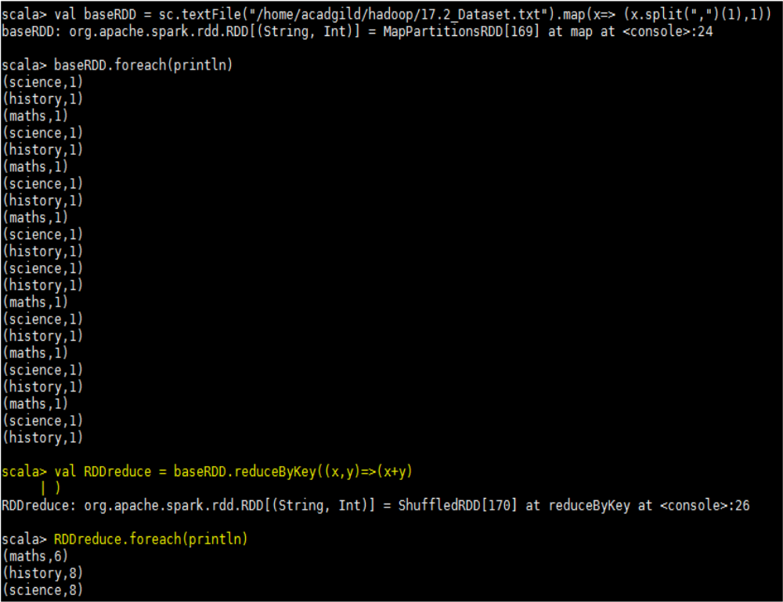
Task1.4 - What is the count of the number of students in the school, whose name is Mathew and marks is 55

Below are the codes,

val baseRDD = sc.textFile("/home/acadgild/hadoop/17.2_Dataset.txt").map(x =>
((x.split(",")(0),x.split(",")(3).toInt),1))

val RDDfilter = baseRDD.filter(x=>x._1._1 == "Mathew" && x._1._2 == 55)

val RDDreduce = RDDfilter.reduceByKey((x,y)=> x+y).foreach(println)

In the first line code, we are reading the text file and creating a tuple RDD as “baseRDD” with name &
marks as key and mapping numerical 1 as value
. 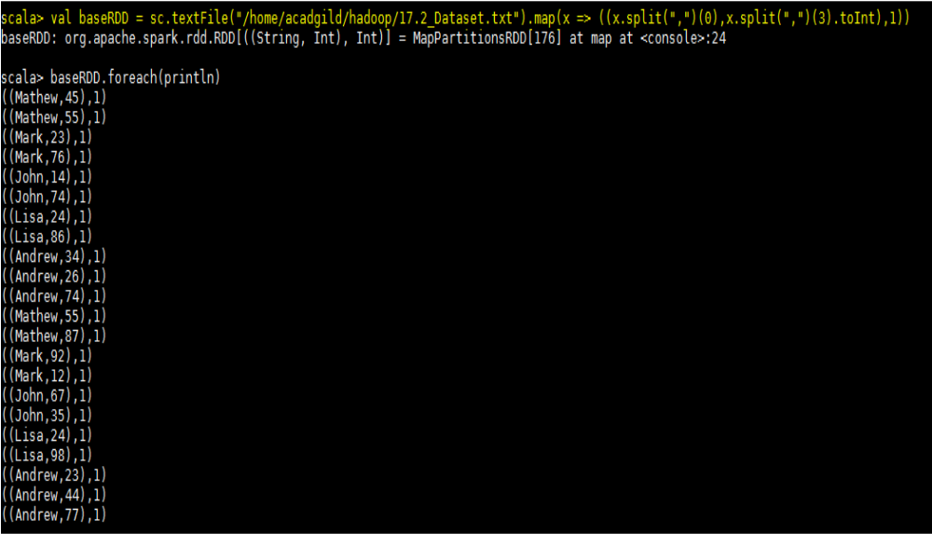
Filter the tuple RDD by providing the condition Mather and mark as 55,
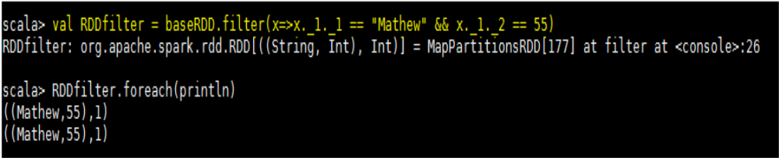

Now we are counting each occurrences using the reduceByKey and the required output is below,
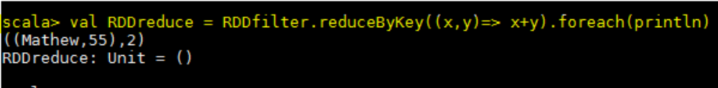

Spark Operations – Problem Statement 2
Task 2.1 - What is the count of students per grade in the school?

val baseRDD = sc.textFile("/home/acadgild/hadoop/17.2_Dataset.txt").map(x =>
(x.split(",")(2),1)).reduceByKey((x,y)=>x+y).foreach(println)

We are reading the text file by creating a tuple RDD with grade as key and mapping numerical 1 as values and reducing the number occurrences using reduceByKey, please see the required output below,

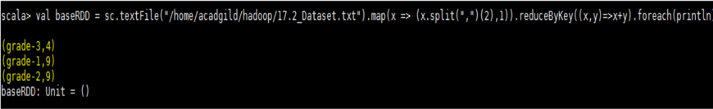

Task 2.2 - Find the average of each student (Note - Mathew is grade-1, is different from Mathew in some other grade!)
Codes,
val baseRDD =
sc.textFile("/home/acadgild/hadoop/17.2_Dataset.txt").map(x=>((x.split(",")(0),x.split(",")(2)),x.split(
",")(3).toInt))
val RDDmap = baseRDD.mapValues(x=>(x,1))
val RDDreduce = RDDmap.reduceByKey((x,y) => (x._1 + y._1, x._2 + y._2))
val StudAvg = RDDreduce.mapValues{case(sum,count)=>(1.0*sum)/count}

First we are creating the baseRDD to read the file and selecting name and grade as key and marks as value,

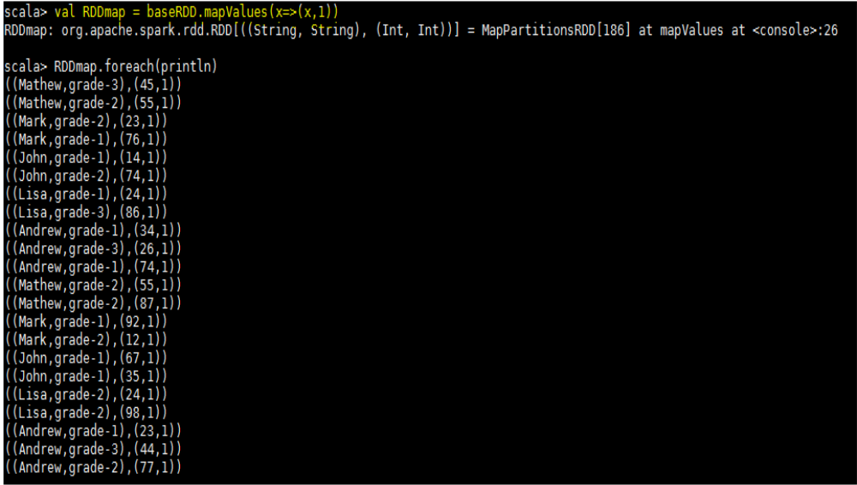

We are using reduceByKey to add the occurrences of marks for each key which is student name and grade,
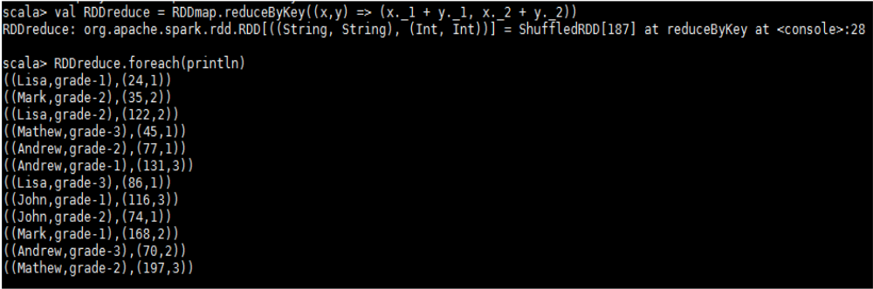

Now we are calculating average by summing the marks and dividing by its count for each key. Below
screenshot shows the final result,
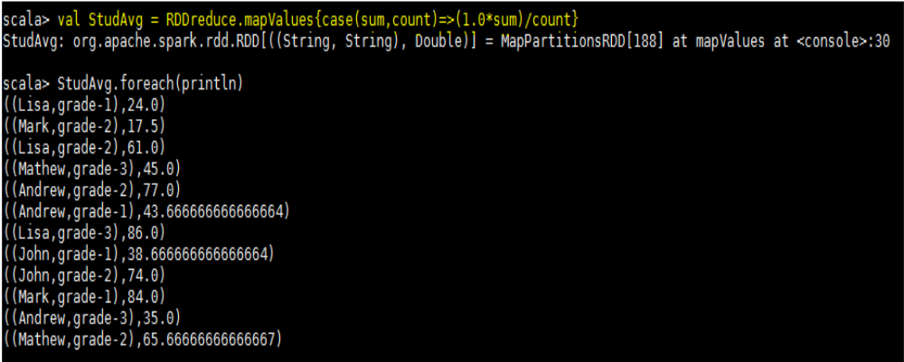

Task 2.3 - What is the average score of students in each subject across all grades?
Codes,
val baseRDD =
sc.textFile("/home/acadgild/hadoop/17.2_Dataset.txt").map(x=>((x.split(",")(0),x.split(",")(1)),x.split(
",")(3).toInt))
val RDDmap = baseRDD.mapValues(x=>(x,1))
val RDDreduce = RDDmap.reduceByKey((x,y)=>(x._1+y._1,x._2+y._2))
val SubAvg = RDDreduce.mapValues{case(sum,count)=>(1.0*sum)/count}

We are first creating baseRDD to read the text file and we are extracting name and subject as key and
marks as value,

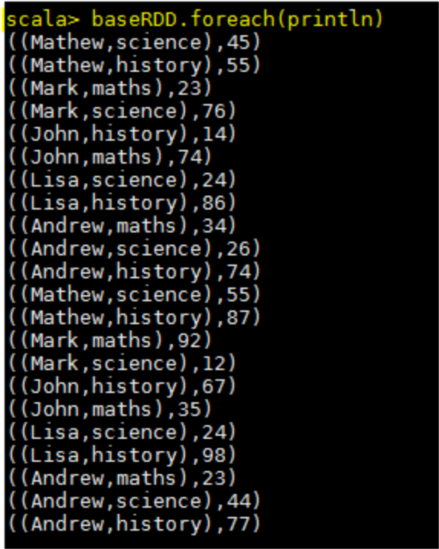
Now using mapValues we are mapping each value with 1-
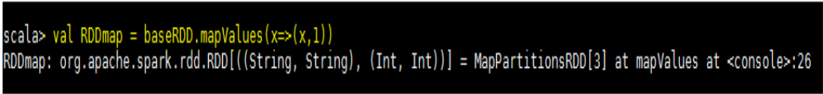
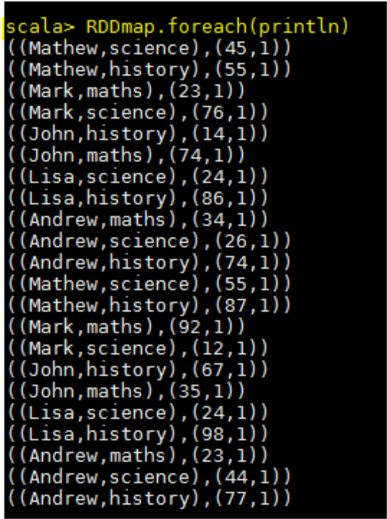
Now we are adding the marks and number of occurrences for each key using reducebyKey and calculating average by dividing the sum of marks and count of occurrences for each key.

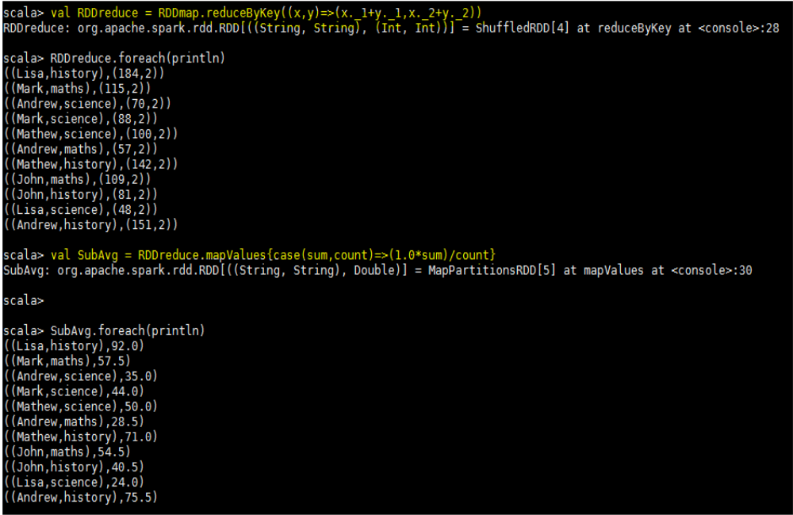

Task 2.4 - What is the average score of students in each subject per grade?
Codes,
val baseRDD =sc.textFile("/home/acadgild/hadoop/17.2_Dataset.txt").map(x=>((x.split(",")(1),x.split(",")(2)),x.split(",")(3).toInt))

val RDDmapvalue = baseRDD.mapValues(x=>(x,1))

val RDDreduce = RDDmapvalue.reduceByKey((x,y)=>(x._1+y._1,x._2+y._2))

val Avg_Grade = RDDreduce.mapValues{case(sum,count)=>(1.0*sum)/count}.foreach(println)

In first step we are creating paired RDD named as baseRDD to read the file and extracting subject and
grade as key and marks as value
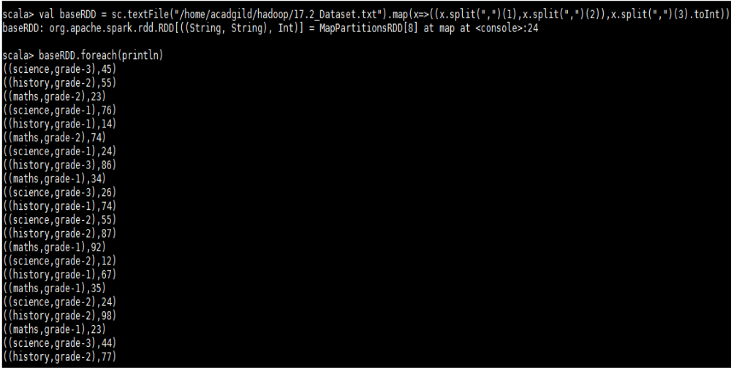

Then we are mapping the values of baseRDD with numerical value 1 using function mapValues
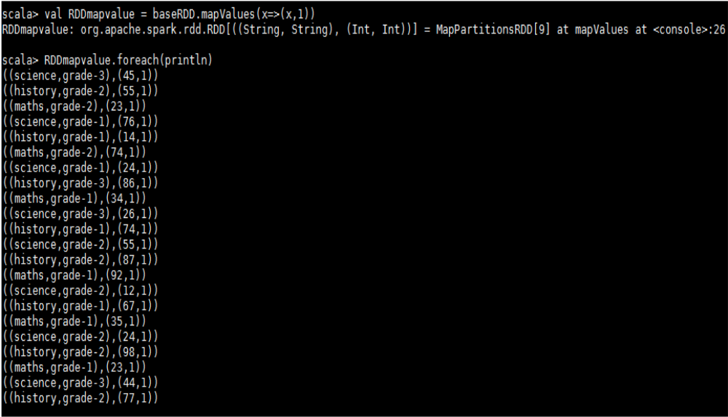

We are adding marks and number of occurrences for each key using reduceByKey
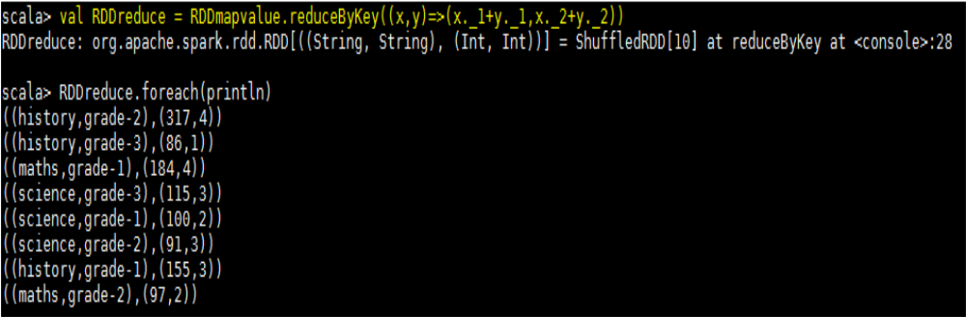
We are calculating average by dividing the sum of marks with number of occurrences and the requested
output is shown below
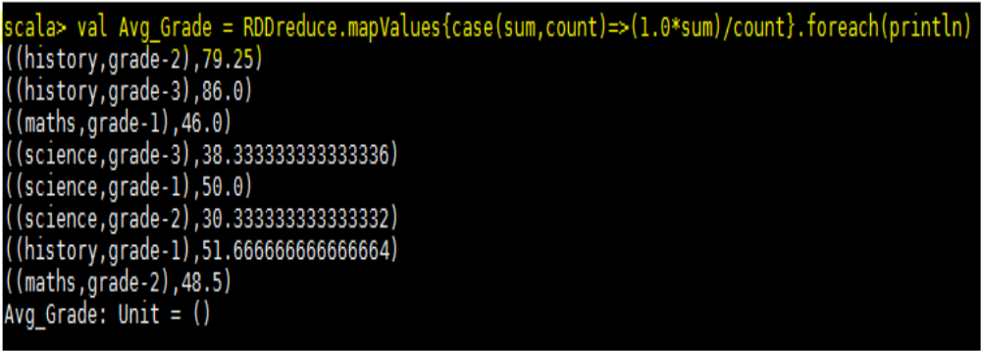

Task 2.5 - for all students in grade-2, how many have average score greater than 50?
Codes,
val baseRDD =
sc.textFile("/home/acadgild/hadoop/17.2_Dataset.txt").map(x=>((x.split(",")(0),x.split(",")(2)),x.split(",")(3).toInt))

val RDDmap = baseRDD.mapValues(x=>(x,1))

val RDDreduce = RDDmap.reduceByKey((x,y)=>(x._1+y._1,x._2+y._2))

val RDDavg = RDDreduce.mapValues{case(sum,count)=>(1.0*sum)/count}

val RDDfiltermap = RDDavg.filter(x=>x._1._2 == "grade-2" && x._2>50).count()

val RDDfiltermap = RDDavg.filter(x=>x._1._2 == "grade-2" && x._2>50).foreach(println)

Creating a paired RDD named as baseRDD to read the file and extracting name and grade as key and
marks as value

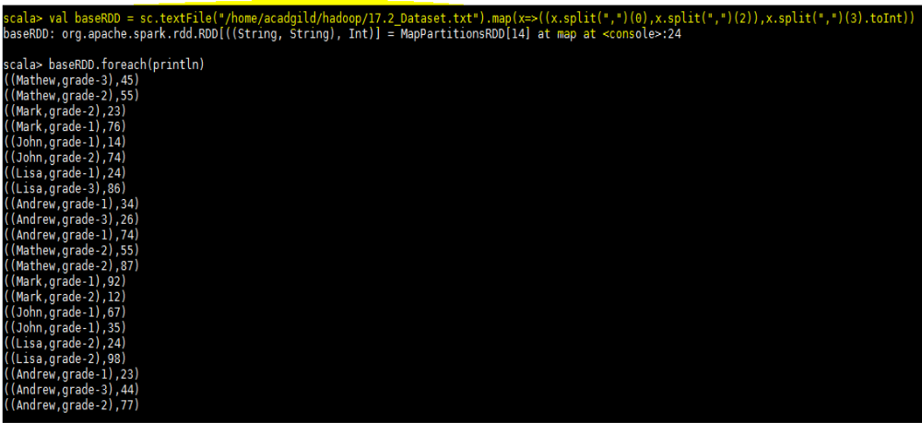

Now we are mapping each value of baseRDD with 1 as shown below

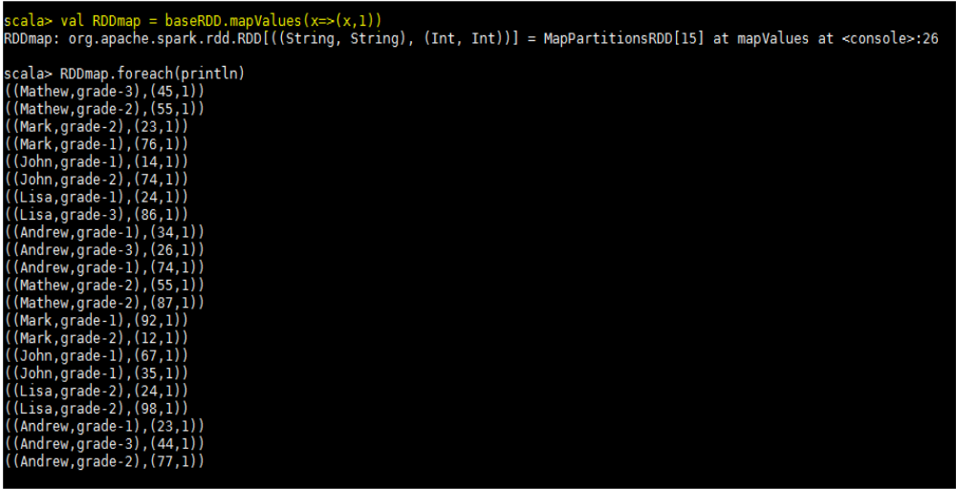

We are adding the marks of subject and number of occurrences per key using reduceByKey function
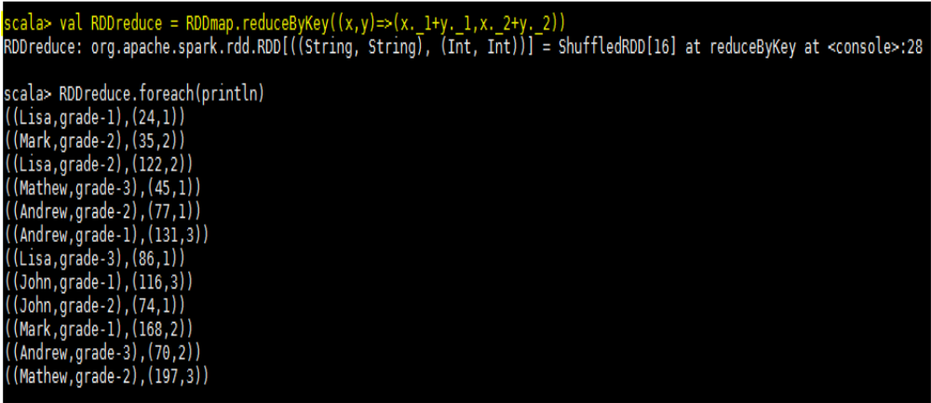

Here we are calculating the average of each student,
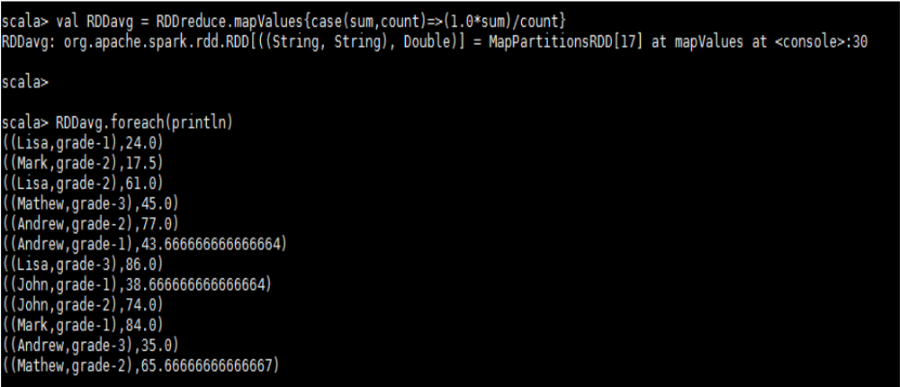

Now in below step we are filtering the above result with student belonging to grade-2 and having marks greater than 50, the number of the counts and the data is shown in the below
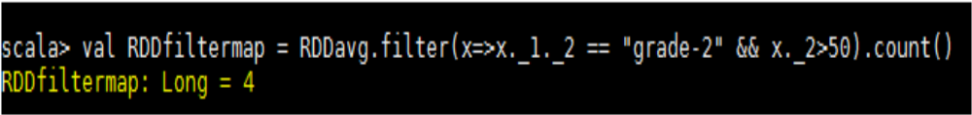
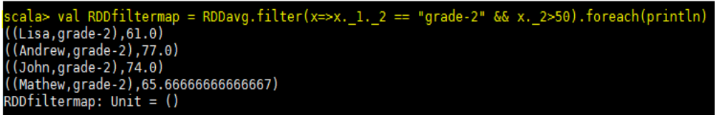

Spark Operations – Problem Statement 3

Are there any students in the college that satisfy the below criteria:
1. Average score per student_name across all grades is same as average score per student_name
per grade

Solution- To find the solution of above problem we will first calculate average of each student across all grades i.e. irrespective of grade. Below is the code used to find the same
val baseRDD1 =
sc.textFile("/home/acadgild/hadoop/17.2_Dataset.txt").map(x=>(x.split(",")(0),x.split(",")(3).toInt))

val studAvg = baseRDD1.mapValues(x=>(x,1)).foreach(println)

scala> val studReduce = studAvg.reduceByKey((x,y)=> (x._1+y._1,x._2+y._2))

scala> val Avg_Stud = studReduce.mapValues{case (sum,count) => (1.0 * sum)/count}

We created a paired RDD named as baseRDD1 by extracting only name and marks,
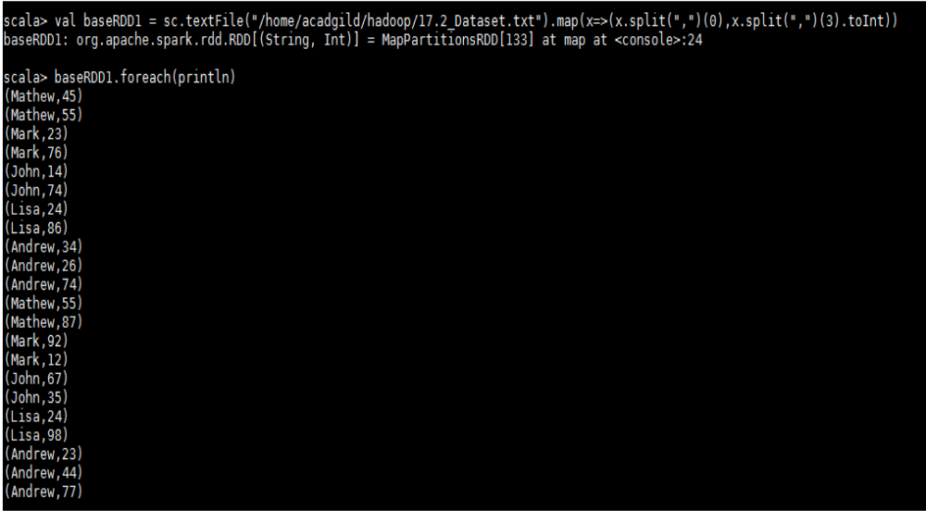

Then we are mapping each value of above RDD with 1,
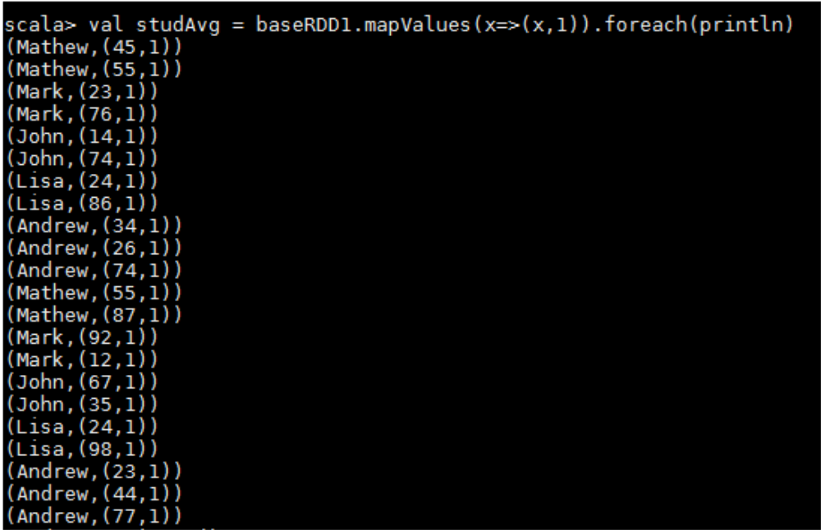

Then we are adding the marks and number of occurrences for each student using redducebyKey as
shown below,
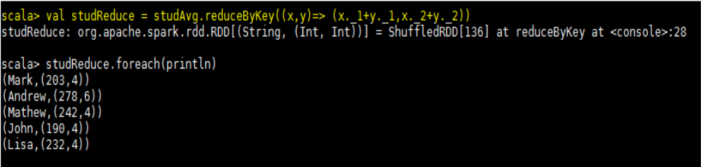

In below step we are calculating the average of each student,

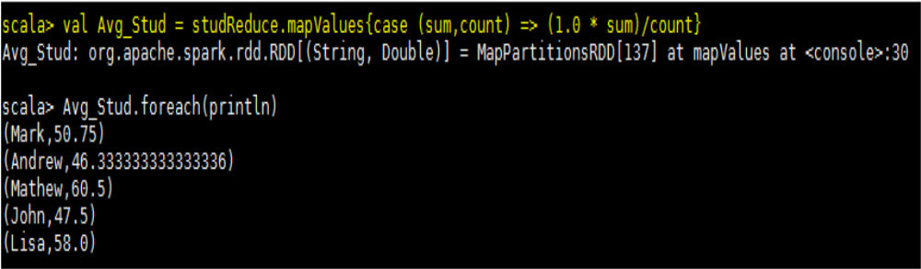

Now the second step of this problem is to find the average of each student per grade. We have used
below code to find,

val baseRDD2 =
sc.textFile("/home/acadgild/hadoop/17.2_Dataset.txt").map(x=>((x.split(",")(0),x.split(",")(2)),x.split(",")(3).toInt)).foreach(println)

val grade = baseRDD2.mapValues(x=>(x,1))

val gradeReduce = grade.reduceByKey((x,y)=> (x._1+y._1,x._2+y._2))

val gradeAvg = gradeReduce.mapValues{case(sum,count) => (1.0*sum)/count}

So first we are creating another paired RDD named as baseRDD2 by extracting name and grade as key
and marks as value from the input file,

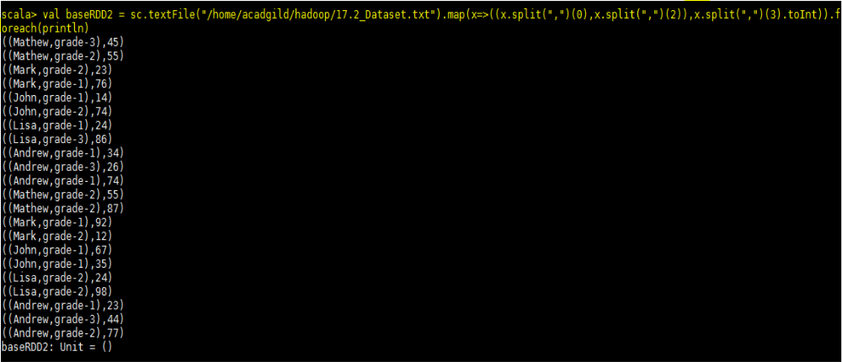

Then we are mapping each value of baseRDD2 with 1 using mapValues function
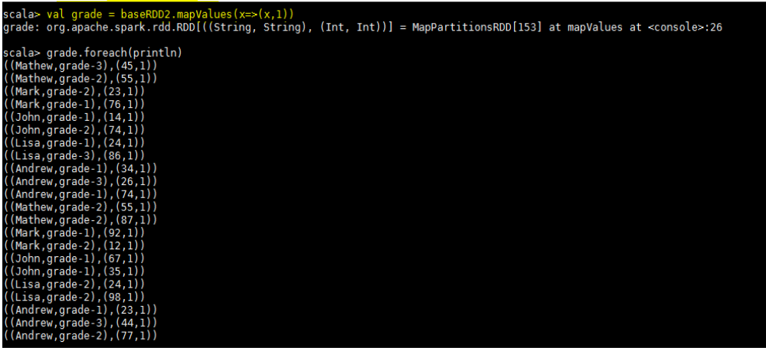

Then we are adding the marks and number of occurrences of 1 for each key using reduceByKey() function

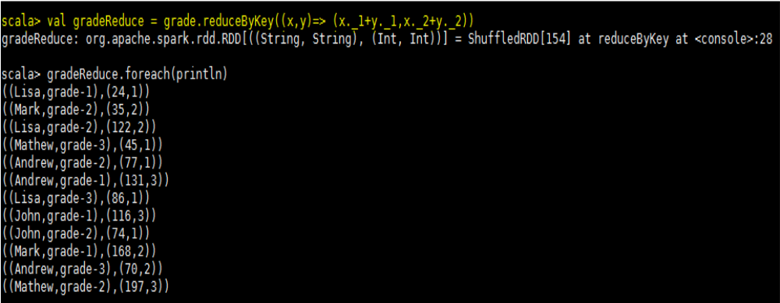

In below step we are calculating average of each key by dividing the sum of marks with the count

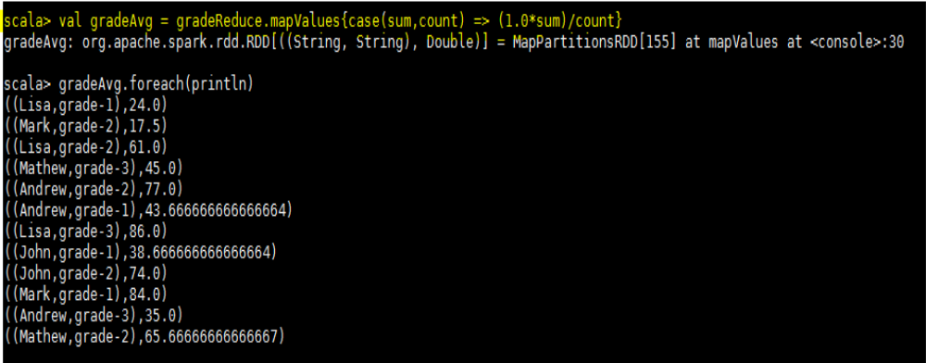

Now to proceed further we are extracting name and marks from above RDD,

In below step we are using intersection function between flatgradeAvg and flatnameAvg rdd’s to find
whether any common student is there.

scala> val flatgradeAvg = gradeAvg.map(x=> x._1._1 + "," + x._2.toDouble)

scala> val commanval = flatgradeAvg.intersection(flatAvg_Stud)

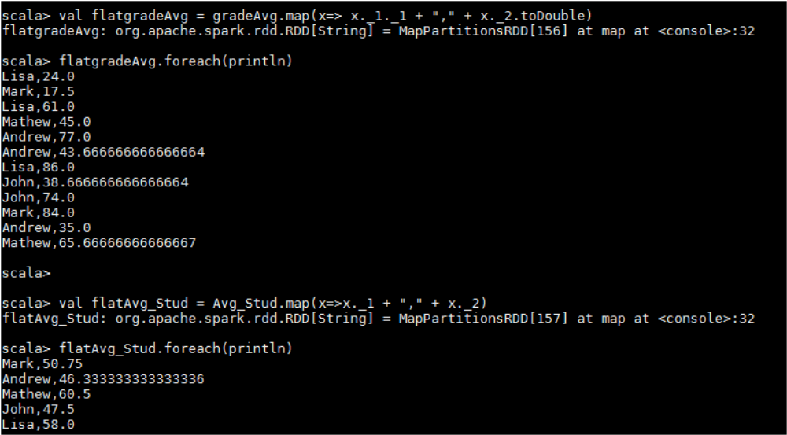

So the command comman.foreach(println) shows that no common students are there having average score per student_name across all grades is same as average score per student_name per grade

